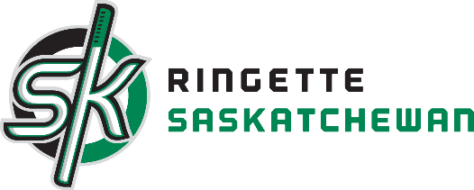

Pursuit of Your Excellence Camp
September 7th-8th 2019

Saturday, September 7th, 2019

Events | Start | End | Rink
Ice Time | 10:30 | 11:30 | C3
Ice Time | 3:30pm | 4:30pm | C2
Sport Medicine Science Council | 7:00pm | 8:00pm | TBD

Sunday, September 8th, 2019

Events | Start | End | Rink
Ice Time | 10:45 | 11:45 | C3
Ice Time | 2:00pm | 3:15pm | C6

