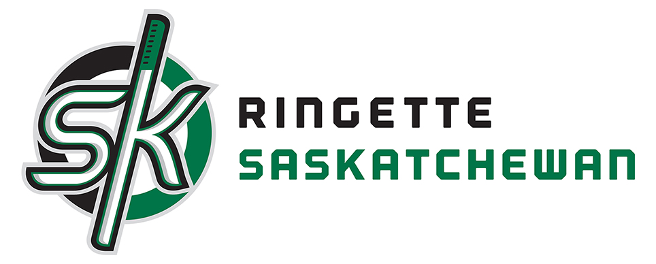

2017 Provincial Package
Team Information Package

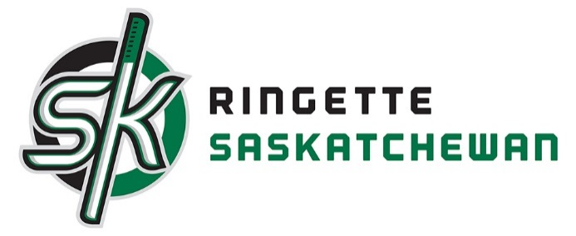

Provincial Championships 2017
Regina/Saskatoon
Introduction
Provincial weekends are fast approaching. RAS is excited for our 2017 Championship and are busy getting prepared. Please read this document through as it should answer all questions for our Provincial weekends.
Please remember our RAS insurance rule this weekend to insure the safety for all. Any persons that are not a member of RAS are not allowed on the ice surface at any time during the weekend. This includes parents on ice for pictures after finals. Please share this with your parents prior to attending the event.
We hope everyone has a great Provincial Championship. RAS Staff and Board of Directors look forward to cheering everyone on.
Tournament Structure
PROVINCIAL CHAMPIONSHIP RULES AND REGULATIONS
- The Ringette Canada Official Rules will be enforced.

- All rules and regulations contained in the RAS Policy and Procedures Manual will apply in their entirety to this competition.

- All teams were required to submit rosters to the RAS office by January 31 for verification. Any changes to these rosters must be reported and approved by the RAS prior to the championship. Therefore, only persons on the approved rosters will be listed on the game sheets and allowed to participate.

- ALL team staff listed on the game sheet must sign in for each game at the RAS control desk at the rink prior to the start of each game.

- Home and visiting teams will be designated on all game sheets. If uniform colors conflict, the visiting team will be required to change. As noted on the team roster forms, teams will be required to wear their home jerseys unless otherwise determined by the R.A.S.

- Illegal sticks include the Stinger 1000, 1001, 5000 and Bunny stick, as well as the Itech R2000 and the Excel stick.

- No jewelry (with the exception of medical alert items) will be permitted for any on-ice participant. Any player found to be wearing jewelry on the ice during the game will be assessed a Delay of Game penalty. This rule will be strictly enforced throughout the championship.

- Teams must be ready to play at the scheduled game time.

- Teams are not allowed on the ice before the officials. Any team going on the ice before the officials may be assessed an Unsportsmanlike Conduct Penalty.

- There will be a 3 minute warm up before the game and a 2 minute break between periods. Teams must be ready to immediately start play when the 3 minute warm up and 2 minute break between periods are complete. There will be no additional time allowed. Any team not ready to immediately start play at the end of the 3 minute warm up or 2 minute break between periods will be assessed a Delay of Game penalty.

- All games will consist of two 20-minute stop time periods. All games will be played until a winner is declared. In the event of a tie at the end of regulation time, consecutive 20-minute sudden victory periods will be played until a winner is declared. Possession of the ring to start the overtime period will be determined by a coin toss, with the home team calling.

- Game winners will be awarded 2 points, while the losing teams will receive 0 points
.
- All rules are at the sole discretion of the on-ice officials and officers/designates of the RAS, as the case may be. Official judgement calls are not subject to protest

Canadian Ringette Championships Tie Breaking Format
Breaking of Ties in Games
All games will be played until a winner is declared.
If the score of a game is tied at the end of regulation time, there will be one overtime period, stop time, which will be sudden victory (i.e. the first team to score will be declared the winner).
If neither team scores during the first overtime period, there will be successive sudden victory overtime periods until a goal is scored to break the tie.
Possession to start the first overtime period will be decided by the tossing of a coin by an on-ice official. The home team will clearly call the toss of the coin prior to it landing. The team winning the toss will get the free pass. The other team will get the choice of ends.
If additional overtime periods are required, possession of the ring for the opening free pass will alternate between teams. The teams will also exchange ends for each overtime period.

Point Structure
Teams receive two (2) points for a win and zero (0) points for a loss. The team with the most points in each division will be declared the top team in that division. The second place team is the team having the second highest number of points, etc.
Breaking of Ties in Standings
When two or more teams have an equal number of points after the completion of the round robin games, the highest of the tied teams will be determined in the following order and considering the "Official Score" of the games.
i) the winner of more game(s) between each other during the round robin will be declared the highest position.
ii) if still tied, the team having the greatest positive difference between goals for and against in games between the tied teams in the round robin will be declared the highest position.
iii) if still tied, the team having the least total goals against in games between the tied teams during the round robin will be declared the highest position.
iv) if still tied, the team having the greatest positive difference between goals for and against in all games during the round robin will be declared the highest position.
v) if still tied, the tied team with the least total goals against in all games during the round robin will be declared the highest position.
vi) if still tied, a coin toss will be used to break the tie.
Important Notes:
1. This procedure shall be followed in sequence until the tie is broken (i.e. one team is eliminated from the tie). Once one team is eliminated from the tie, the procedure reverts back to (i).
2. This procedure, in most cases, will declare the team in the HIGHEST position. However, in some cases, the procedure will declare the LOWEST position between tied teams, and that team shall be dropped from the tie breaking procedure (i.e. the top two teams remain tied). In these cases, the procedure shall also revert back to (i) in order to break the tie between those teams that remain tied.
3. In all cases, the maximum difference (spread) between goals for and against in each game is seven (7) goals. This is the "Official Score".
4. Following the completion of round robin play, 1st, 2nd, 3rd and 4th place teams will be determined as a result of the application of the normal tie breaking procedure (as outlined in i) - vi) above). Should one team be eliminated from the bronze medal round play as a result of the application of the normal tie breaking procedure, a "mini-game" will be played in order to advance the 4th place team to the medal round.
Consult the current Canadian Ringette Championships Technical Package for further information on the conduct of mini-games
U14AA/U16A/U16AA/U19A Playoff Format
Best 2 of 3 series. Winner of 2 games in the series is considered Provincial Champion and will be ‘Team Saskatchewan’ at Westerns or Nationals. Game number 3 is only ‘if necessary’. If the 3rd game is not needed the home team will get the awarded the ice to use as a practice.
Opening Ceremonies
Each team is strongly encouraged to attend opening ceremonies. Teams are encouraged to wear their team colors or jerseys. Your team will be introduced as your team does a walk around the ice. We encourage teams to make a banner to carry on the ice as your team walks in to show off your excitement and team spirit.
Skills Competitions
These 3 events require your athletes.
- U14AA – Requires 2 participants per team per event (4 participants per event)
- U16A/U16AA – Requires 1 participant per team per event (4 participants per event)
- U19A - 2 participants per team per event (4 participants per event)
- U14B - 1 participant per team per event (5 participants per event)
- U16B - 1 participant per team per event (4 participants per event)
- U19B - 1 participants per team per event (5 participants per event)
Please submit names of participants for each event to technicaldirector@ringettesask.com by January 25, 2017.

SKILLS COMPETITION FORMAT
All players must wear full equipment, including team jersey
Time: Maximum 2 hours

Events:
- Fastest Skater
- Most Accurate Shot
- Show Down (Goalie vs Player)

Order: Each team shall provide the number of players listed above for each event. Players should compete with players from their own divisions, with each age group competing separately. All age groups run through one event, then the next set of competitors run through the second event, etc.

i.e.) U14 fastest skater, then U16 fastest skater, etc.

EVENTS

1. Fastest Skater
Nets will be at the hash marks, pylons on the blue face off dots at each end of the ice. Two participants compete at one time. Players begin on opposite sides of the center red line. Once the whistle is blown, both participants skate one full lap around the rink, as outlined by the net and pylons, back to their original starting position. Time will be recorded. The skater with the fastest time wins!

2. Most Accurate Shot
Targets are set up in each of the four corners of net. One player at a time will have six opportunities to try and hit all four targets. Rings will be set up in a line parallel to the goal line at the hash marks. The stationary player using the least number of rings to hit all four targets will be declared the winner. If participants are tied, additional rounds may be needed to determine a winner.

3. Showdown
This event requires a skater and goalie from each team. Four rings are set up at the blue line. Players start at the blue line with a ring and once the whistle is blown, skate in to take a shot on net and then return for the next ring. Shooters must proceed in a forward motion towards the net, but are allowed to deke, use their backhand, etc. and cannot score off a rebound. In other words, it is similar to a penalty shot. This process is to be repeated until all the rings are gone. The skater with the most goals wins, while the goaltender with the least goals against wins.
Officials
Officials for the weekend were chosen based on officiating level and rank. Each event will have an official supervisor on hand to watch and evaluate each official for their games over the course of the weekend. Officials are then provided with their results at the conclusion of each evaluation.
Minor Officials
Home team provides scorekeeper and shot clock operator and the away team provides the time keeper. Please make sure you arrange this with parents and volunteers prior to your game so everyone is prepared and the game can start on time.
Awards
MVP Player of the game
RAS Staff, Board Members and Volunteers will be identifying a player in each game as the MVP. Votes will be tallied and the award will be presented during the final game of the winning player. Coaches please feel free to share a vote at the end of each game if you saw an individual excel during that game.

Most Sportsmanlike Team
The definition of a sportsmanlike individual/team is someone that exhibits qualities that are fair, in good temper, and have courtesy in all situations on and off the ice.
Ringette Saskatchewan will be awarding a team that shows these qualities during this weekend. We ask coaches, parents, managers, officials, and volunteers to observe other teams that exhibit sportsmanlike quality on and off the ice. If you see a team or individuals on a team exhibiting these please come nominate them.

RAS wishes everyone the best of luck and may we all have a fun weekend together!!

