**CWG Meet In The Middle Ringette Challenge**

**Winnipeg, MB**

**October 4-8, 2018**

**Periscope Instructions – Watch Live & Recorded Video Feed**

**Instructions for Viewing Live Video Feed**

1. Download the Periscope App on your Mobile Device (if you already have an account, proceed to step #5)



* + Available on either Apple App Store (Apple Device) or Google Play (Android Device)
  + Or Go to Website www. pscp.tv on your desktop computer or laptop

1. Click “Create New Account”
2. Create a new account through:
   * Twitter, Facebook, Google (gmail), or Phone Number
   * Most use Google (gmail) or Phone Number (Cell)

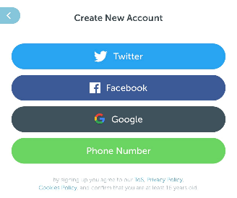

1. Option to either “Enable Notifications” to be notified when games are Live or “Skip” to option
2. Search for People to Follow by clicking on the below Icon in the bottom right of the screen



1. Click the below magnified glass icon on the top left corner on the screen



1. To add Both Red & Blue Rinks, In the Top Search line type:
   * “CWG Meet In The Middle Red”
     + Click the below “Add + icon” to Follow
   * “CWG Meet In The Middle Blue”
     + Click the below “Add + icon” to Follow



1. Click the below Television icon on the bottom left corner of the screen



* + Live and Recorded Games will be listed for each Rick

1. Click the applicable game to view and watch based on your team’s schedule