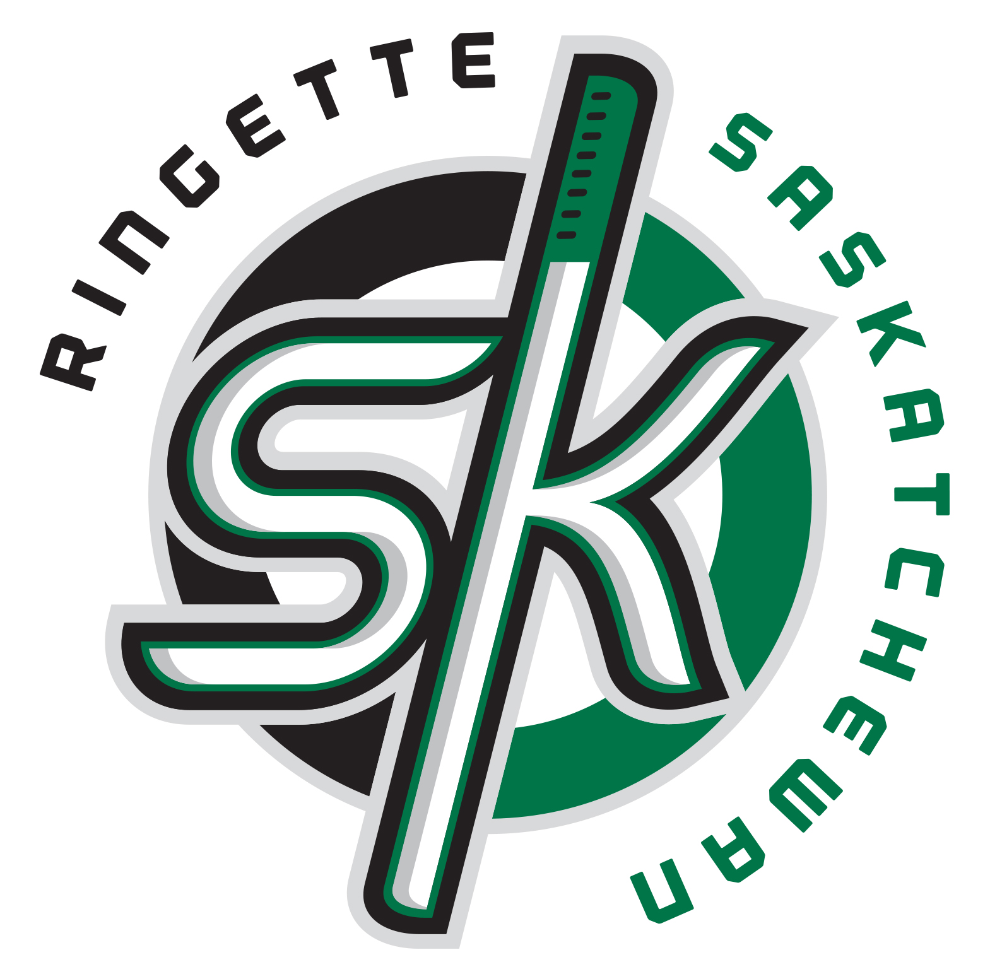

Officiating Mentorship Program

Requirements
- Mentor must be a Level 2, 3 or 4 Official
- Must provide on ice shadowing and advice to a Level 1 Official, complete and submit required documentation
- Please be advised that the maximum number of mentor forms accepted on a certain official will be two. It is important, therefore, that the Mentors coordinate with others in their area to ensure that as many officials are seen as possible and there are few duplications.

Duties
- Contact Level 1 Official prior to assignment. Introduce yourself, confirm the assignment date and time and explain the mentoring process.
- Arrive 20 minutes prior to scheduled game time. Must dress in complete officiating equipment
- Explain to coaches that you will be providing guidance to the assigned official, but will not be making any calls in the game. All questions, etc should be directed to the assigned officials.
- Enter ice surface with Level 1 Official and shadow throughout game. The mentor does not make any calls, but merely provides guidance and assistance on matters such as positioning, mechanics and rule interpretation.
- Following the ice time, the mentor must complete the mentoring form and have the Level 1 Official sign. Leave a copy with the Level 1 Official, retain a copy and send in the remaining form to the RAS office
- Mentors will receive $20/form received into the RAS office. Payment will be made in Dec. and April.

Time Frame
- Payment of $20 per mentorship will be issued twice; once at the beginning of December and again at the beginning of January. As the intent of this program is to provide feedback at the very beginning of the official’s season, the program will officially end on December 31st.

