RINGETTE SASK MASK
ORDER FORM

Name:
Contact #:
Mailing Address:

QUANTITY | PRICE | TOTAL
 | $15.00

Price includes shipping within Saskatchewan
Payment accepted via cheque or e-transfer to executivedirector@ringettesask.com
Return this form via email to technicaldirector@ringettesask.com
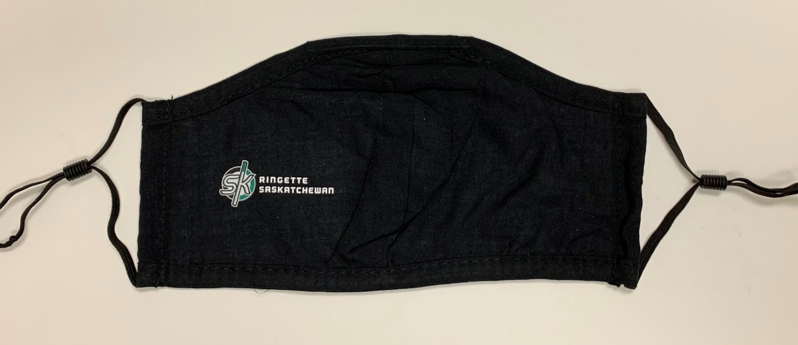
Only 200 so first come first serve.

