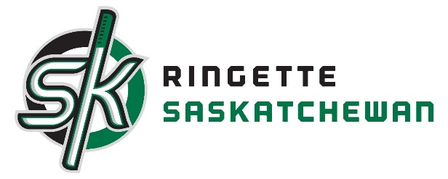
RAS High Performance Coaching Program
Ringette Saskatchewan has introduced a High Performance Coaching Program to enhance more coaches being certified in NCCP Competition Development. You will find attached the NCCP Competition-Development Multi-Sport Modules schedule from the Coaches Association of Saskatchewan as well as the Ringette Specific Competition development course.
Also attached to this will be the Competition Development Pathway to help assist coaches in becoming NCCP Competition Development trained.
We will be adapting this program yearly to meet the needs of our High Performance coaches.
Criteria for this program:
- Need to be coaching a high performance team this year (U16 – Open “A/AA”)
- Need to have expressed interest in applying as one of our Canada Winter Games coaches
- Modules from the Coaching Association and the Ringette Specific modules will be funded if taken in this current year.
This RAS High Performance Coaching Program will be issued on a reimbursement basis. The application for assistance is enclosed. Receipts for expenses related to this program must be attached. Application for assistance can be made when the above criteria have been met. The amount of money will be distributed dependent on the number of individuals interested in this program.
Application deadline will be at the end of our fiscal year May 31, 2018 as another Ringette Specific module will be happening in the beginning of May. That date will be posted as soon as Ringette Canada releases the date.
No reimbursement prior to will be accepted.
If you have any questions, please contact the office.

Ruchelle Himmelspeck
Executive Director Ringette Saskatchewan
Ph. (306)780-9432
Fax (306)780-9480
Email: executivedirector@ringettesask.com

NCCP Competition Development Multi Sport Modude dates Fall 2017 coming soon.

Ringette Specific
Ringette Specific – Competition Development - $350
- Performance Planning
- Planning a Practice
- Analyze Technical and tactical Performance
Offered weekend of Aug 18-20, 2017 in Calgary.

RAS High Performance Coaching Program
Reimbursement form

Coaches Name:
Date:
Reimbursement sent to: Name:
Address:
Postal Code:
Staff Position:

Module | Date taken | Expenses Accrued | Amount Requesting

#of receipts sent: Reimbursement Requested: $
Signature of Coach: Date:

