Ringette Saskatchewan

Goalie Clinic Training Manual

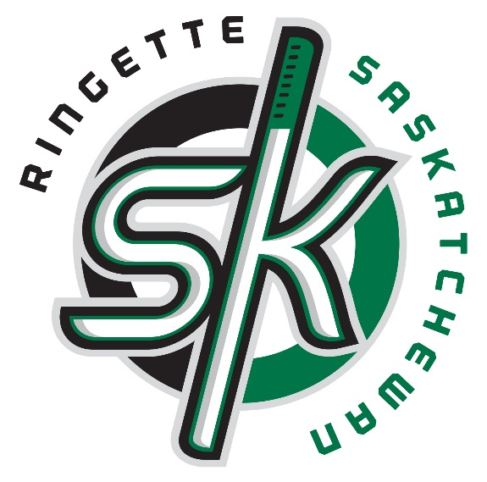

Some content supplied from the Ringette Canada NSIP Instructor Manual

RAS Goalkeeping Manual

Table of Contents
Introduction Page 2
Goalkeeping Skills Preview Page 4
Proper Techniques Page 5
Communication and Team Play Page 14
Rules and Regulations Specific to Goalkeepers Page 15
Skills and Drills Page 16
Blank Practice Templates Page 25

Introduction
Ringette is a winter sport very similar to hockey. There are many differences between the two sports. One of these differences involves the goalkeepers. In both sports, the goalkeeper has one main job to perform – stop the opposition’s shot, which is a potential goal. Along with this primary job, there are many additional jobs which, if performed correctly, can assist the goalkeeper in performing her primary job.
In order to perform goalkeeping duties, a goalkeeper must be able to understand various concepts and perform certain basic skills. Once a goalkeeper has mastered the concepts and basic skills, she/he can then develop her/his own style which will suit her/his strengths and limit her/his weaknesses.

Equipment
Skates
Goal skates or hockey skates may be worn. The Goalkeeper is the only player permitted to wear special goalkeeper skates. Goalkeepers may prefer to have their skates sharpened differently (not as much hollow ground, but this is not mandatory) Sharper skates that have a good edge are key to efficient movement.
Goalkeepers Pads
Goalkeeper pads are mandatory in Ringette. The size and weight of the pads selected will depend on the age and size of the individual and any league regulations.
Pants
Most goalkeepers prefer to wear hockey goalie shorts. Hip, tailbone and genital protection must be worn and is provided in many Ringette and Hockey girdles. Hockey pants may also be worn. They will provide good protection for the thighs and much of the mandatory equipment for hips, tailbones and genitals.
Chest Protector
A chest protector must be worn by all goalkeepers. There are chest protectors specifically designed for females. A protector for shoulders and arms is also recommended.
Gloves and Blocker
Goalkeepers have personal preferences as to the type of gloves they use. While the use of padded gloves in mandatory, it is recommended that goalkeepers utilize a blocker on their stick hand as it provides a larger surface area to block shots. For the catching hand, a Ringette, Hockey or other padded glove is worn. These gloves are usually available from the league equipment room so the goaltender can try different catching gloves to find their preference.
Throat Protector
It is recommended that the goalkeeper be equipped with a throat protector (free moving polyethylene throat protector, attached to the helmet) in addition to the mandatory BNQ certified neck guard.
Helmet
The goalkeeper can choose to wear a player helmet with a certified ringette cage. They can also wear a molded goalkeeper helmet with a ringette mask. There is currently one Ringette goalie helmet and mask combination approved by the Canadian Standards Association (CSA). The approved OTNY goalie helmet model is the OR2000 (in size JR and SR) with approved Type C face protector model OR01 (in size JR/SR).
Stick
Goal sticks should be selected according to the following:
- Height of the player
- Goalkeepers style
- Stick weight
- Stick length
- Lie of the stick (indicated by the number printed at the top of the shaft). The blade of the stick should lie flat on the ice surface when the goalkeeper is in their regular stance.
Note: sticks should always be sized while the goalkeeper is wearing skates.

Goalkeeping Skills Preview
The following chart outlines the skills Ringette goalkeepers should learn, according to their age groups.
Skill | 8-10 yrs | 11-13 yrs | 14 yrs +
Proper Warmups | * | * | *
Stance | * | * | *
Proper Grip | * | * | *
T-Push | * | * | *
Shuffle | * | * | *
Telescope | * | * | *
Retreat | * | * | *
Stick Techniques - cushioning | * | * | *
Stick Techniques – deflecting |  | * | *
Stick Techniques – clearing |  | + | *
Finding Posts | * | * | *
Hugging Posts | * | * | *
Angles | * | * | *
Single Knee Drops |  | + | *
Butterfly Drops | + | + | *
Blocking Shots | * | * | *
Catching Ring | +1 | * | *
Throwing Ring | * | * | *

+ - skill level of individual determines
+1 – must first learn to bat ring down – catching comes later

Proper Warm up and Skating
Teaching Points
- A goalkeeper should participate in as many skating drills in a practice as they can. This will help them with their agility in the net.
- There are also many goalie specific skating drills that can be practiced.
- Goalies should always warm up before taking shots. This can include an off-ice warm up.
  - The goalie should skate first to warm up their muscles
  - Then they should find a place on the ice to stretch, focusing on the large muscles in the legs and groin
- Shooters should always shoot directly at the goalie at the beginning of a warm up and progress to shooting at corners.
  - Remind the shooters not to deke in the beginning of the warm up and to give the goalie a chance to recover to their ready position stance
  - Remind goalies that they should try to recover to the ready position stance between shots even if it means letting some shots past them in warm up.
    - Don’t attempt to make big saves before they are warm!

Stance
Teaching Points
- Feet comfortably apart for balance and mobility
- Knees bent, weight slightly forward resting on the balls of feet
- Glove hand in ‘ready’ position; arm extended out to the side, glove hand half way between knee and shoulders. Glove hand and blocker hand are slightly in front of the body
- Stick on the ice 10-15 cm from toes; blade straight

Errors
- Feet to far apart or too close together – poor mobility; vulnerable through the legs and above the stick
- Standing up straight – minimum side movement; too vulnerable in corners
- Stick comes off the ice – making along the ice open for shorts
- Glove hand against body (posting) – gives less time to react to shot
- Glove hand held low at knees – gives less time to react to shot
- Stick too close to pads – fall forward less mobility
- Stick too far away from pads – tendency to go down; stick will be angled and shots can deflect through the legs
- Crouching too low- less mobility; opens the top portion of the net
Grip
Teaching Points
- Ideal position of index finger is extended down the shaft of the stick for control over ‘flapping’ of stick for hard shots.
- Remaining fingers and thumb wrap around stick (shake hands)
Note: Select proper lie of goal stick according to height and stance so that stick feels comfortable and lies flat on ice.

Errors
- Holding stick too high on shaft, flapping will occur when the ring is shot and makes contact with the stick
- Grip stick too tightly, difficult in handling and shooting ring away.
T-Push
Teaching Points
- Start in a ready position stance
- Place weight on pushing foot – back foot forms top of ‘T’
- With opposite foot point in the direction of travel to form the shaft of the ‘T’
- Bend knees, head up, keep eyes on the ring
- Glove should be in ‘ready’ position, stick on ice and push off
- Recovery of the pushing foot should be low to the ice, keeping face of pad forward towards the play
Errors
- Recovery leg not facing play
- Standing up straight – loss of balance, improper position

Shuffle
Teaching Points
- Start in a ready position stance
- Weight on pushing foot
- Slide lead foot 20-30 cm in direction of travel with both pads facing the play
- Transfer weight to lead foot
- Recover trailing foot until proper stance is back to starting position
- Repeat until position is met
- Maintain proper stance throughout
- Keep stick on the ice, 15-20 cm from feet
Errors
- Not transferring enough weight to keep in constant motion
- Standing up straight
- Straightening up and then crouching back to stance; bouncing or bobbing up and down
- Crouching down too far
- Not keeping eye contact with the ring and player
- Lifting stick off the ice

Telescoping
Teaching Points
- Start out in crease in proper stance
- Point toes slightly outwards
- Push legs apart with quad and hip musculature
- When feet are 60-90 cm apart, point toes inwards and pull legs together again with strength of groin muscles. The goalie will be creating an egg shaped pattern.
- Ensure goalie is staying balanced and has a good inside edge of skate.
Errors
- Feet too far apart, loss of balance
- Toes pointed in too much, not allowing forward motion
- Eyes are always on the ring, not the player. Goalie should have situational awareness by having head on a swivel in down times and practice using peripheral vision to observe where potential passes can occur and scoring threats lie.
- Body and/or stick bobbing up and down out of position
- Crouching too low
- Standing up straight
- Lifting stick off the ice

Retreating
Teaching Points
- Backing in to crease in proper stance
- Point heels slightly outward
- Push legs apart with quad and hip musculature
- When feet are 5-7 cm apart, point heels inwards and pull legs together again
*Note – simply skating backwards slowly in stance is also a good method of retreating

Errors
- Same as telescoping
- Pushing too strongly with one leg, causing goalkeeper to be off center in the net
- Not retreating fast enough and shooter goes around goalkeeper

Cutting Down Angles
Teaching Points
- Telescoping out towards the ring in order to limit the amount of net accessible to the shooter
- Retreat back into the crease as the shooter comes closer to the crease.
- Keep body between center of net and the ring. Do not play top of the Ringette crease where you can easily be deked, if the shooter is close to the crease.
- Watch for potential passes to other shooters around the crease.
Errors
- Pushing with one-foot unequal pressure in feet, causing off centered position
- Angle in relation to play – stay in centre between ring and net; the goalie will be out of position if they are lined up on the shooter’s body.
- Not retreating fast enough and the shooter goes around the goalkeeper
- Retreating too much and thus exposing a great deal of open space in the net to the shooter

Stick Techniques
Teaching Points
- Cushioning, if stick is in the proper position 10-15 cm from feet when ring hits the stick, it should ‘deaden’ in the crease
- Try to avoid rebounds
- Deflecting, turn stick to re-direct ring to corners or teammates
- Lean in the direction you wish the ring to go and slide stick’s blade on ice to desired angle to re-direct the ring
Errors
- Watch lie of stick, this is extremely important to the quality of cushioning and deflecting the ring

Clearing Ring
Teaching Points
- The blocker hand slides up to the butt end of the stick, and the glove hand holds the stick at the top of the shaft. Index finger points downward on the back of the shaft.
- Ring is positioned at the stick side of the goalkeeper
- Weight is put on the stick, and the pass is made with a sweeping action across the front of the body
- Head faces the target and the follow through action completes the pass with the stick pointing at the target
- Ring can be cleared from inside the crease
- Ring can be passed with the stick, over the blue line, by the goalkeeper
Errors
- Stick lie – heel or tip of blade on ice only
- Balance - incorrect stance
- Anticipation – timing
- Swinging the stick too high
- Swatting at the ring rather than a smooth sweeping motion

Finding Posts
Teaching Points
- Stick side – use shaft of stick and swing it back and forth until it hits the post
- If post is not found, telescope back and try again
- Stick blade can come off ice
- Glove side – swing blade of stick across body until post is found
- Feel for the post behind you with your glove hand
- Keep eyes on ring and player at all times
Errors
- Turning full body around to find posts
- Taking eyes off ring or player in front of the net
- Swinging stick too much, leaving along the ice open
- Butt end pointed directly backwards causing it to get caught in the net mesh
- Poor anticipation, timing – searching for posts too late

Hugging Posts
Teaching Points
- Place elbow outside post
- Get the body as close as possible to the inside of the post
- Place heel of skate against the inside of the post
- Maintain your basic stance with feet approximately in a 45-degree angle to the goal line
- This will keep body in a position to T-push across the crease to telescope out if needed
- Stick blade can be angled out on stick side or across body on glove side to block passes through the crease.
- Glove hand can be extended to block raised passes through the crease.
Errors
- Standing too far from post, allowing room for ring to squeeze between body and the post
- Poor stance causing incorrect balance and poor T-push or telescoping out of position
- Parallel to goal crease vulnerable position
- Not leading with the butt end of the stick around the post so that it gets stuck inside the post.

One Knee Drops
Teaching Points
- Start in a T-push or shuffle
- When feet are approximately 1 m apart, drop the knee of pushing foot to ice
- Keep face of pad forward
- Place stick so that it covers the space on ice
- Glove hand is always in ‘ready’ position
Errors
- Pad face flat on ice (incorrect)
  - Correct foot position – back of heel on ice will keep pad face pointing out
  - Toe on ice will cause incorrect facing of pad
- Improper balance
- Body should be centered at all times between the ring and the net
- Be sure stick is kept on the ice

Butterfly Drop
Teaching Points
- Start in a ready position stance
- Both feet slide out from under the goalie and out to the sides
- Pads stay flush with ice surface with the pads facing the play
- Stick covers space on ice
- Glove hand always in ‘ready’ position
Errors
- Same as ‘One Knee Drops’
- Falling forward
- Letting legs slide out and falling on their butt.
Recovering from Down Saves
- When recovering from a down save (i.e. butterfly, one-knee drop/pad save), the goaltender shoulder ALWAYS recover on their outside leg
  - i.e. if rebound or ring travels to left side of goaltender, recover on right leg to push across crease. Or if rebound or ring travels to right side of goaltender, recover on left leg to push across crease
Teaching Points
- Eyes and head turn to ring first. ALWAYS find the ring first.
- The movement of the head should help square up the goaltenders shoulders and hips to the direction they wish to move
- Tuck inside leg under their hip
- Outside leg lifts and finds inside edge of skate. Weight is typically on inside leg at this point
- Transfer most of weight on outside leg as goaltender pushes to stand up
- Push off outside leg in direction of ring using appropriate pattern (i.e. shuffle, t-push, c-cut).
- Stick and gloves lead them across crease
- Eyes never come off of the ring
* If rebound comes out directly in front of goaltender, use most efficient leg in recovering
Errors
- Get up on inside leg or same leg every time.
- Head and eyes do not turn first and lag behind in the movement (i.e. they end up moving “blind” to the play)
- Head and hips don’t turn together (usually as result of lack of head movement)
- Too much weight on outside leg when attempting to recover it from ice
Blocking Shots
Teaching Points
- Getting body in front of shot
- May have to T-push, shuffle, drop, slide, dive…...to get there
- Get back up and in position as quickly as possible
- Cushion the shot with the body or stick or knock it down within the crease to prevent rebounds
- Always watch the ring hit the body or stick
- Saves can include:
  - Pad saves
  - Toe/kick saves
  - Stick saves
  - Butterfly saves
  - Glove saves
  - Blocker saves
Errors
- Only using an arm or leg to stop a shot is risky
- Batting at the ring in an uncontrolled manner will cause deflections and possible goals

Catching the Ring
Teaching Points
- With glove hand, catch like a Frisbee
- Most goalkeepers will find it easier to bat the ring to ice in the crease
- Easier to catch ring with a ski or broomball glove, than a hockey type glove
Errors
- Timing – goalkeeper may `follow through ‘after trying to catch the ring, missing it completely

Throwing the Ring
Teaching Points
- Goaltenders should only throw the ring from a standing position
- Pick up ring in glove hand
- Hold ring parallel to ice
- Draw back across chest then swing arm forward in desired direction
- Release the ring (like a Frisbee) low to the ice
- It is a 5 second count violation to throw the ring goes over the blue line
Errors
- Timing and anticipation
- Ring not landing flat
- Not looking before throwing
- Taking more than 5 seconds in a violation
- Throwing the ring too high in the air causing bouncing (this makes it harder for their teammate to pick up the pass and easier for the other team to intercept)
Note: The goaltender should not throw the ring to a teammate who is directly in front of the net.
Recovering from a Save
Teaching Points
- Try to return to the ready position stance after each save if possible
- Always face the play so the goalie can prepare to make another save
- Use legs only; try not to push on legs with hands to return to ready position stance
- If on butt, roll to stomach or knees and then recover
  - Older players can recover directly from their butts by bending their knees up and flaring their feet out to the side; then pushing off the ice with one hand

Communication and Team Play
To date we have discussed the basics of goalkeeping. Besides the actual act of stopping the ring and understanding the concepts behind the job, there are still other facets of the game a goalkeeper must become familiar with. The goalkeeper is probably the only player, because of the nature of the position, who can see the whole play and its development. Therefore, it should follow that she/he should inform teammates of various events such as potential screens, pics or crease passes that may be developing behind them. Communication is a vital tool which the goalie must utilize to help the defensive unit perform its duty. When she/he informs her teammates of various events, she/he should do it loudly, quickly and with few words. She/he should also inform her/his teammates of things that they may be doing which are preventing the goalkeeper from doing her job. For example, the defence may be backing in towards the goal too far or the defence may be screening her/his vision of the ring. She/he must convey this information to her/his teammates in a constructive way which will help defend against a goal, not after.
When her/his teammates gain control of the ring the communication responsibility is not over. Once again her/his teammates may be engaged with an opposition player and cannot see her/his options. The goalkeeper can assist by not only directing the ring carrier, but also her/his other teammates. In older divisions, the goalkeeper can also warn her/his teammates that the shot clock is running out.
So we can see from reading this information that a goalkeeper`s job is not simply stopping the ring, but much, much more. If a player aspiring to become a goalkeeper tries to perform the points suggested here, she will not only be on the road to becoming a solid goalkeeper, but a solid team player as well.
There are may drills available to assist goalkeepers in the development of their skills. A live imagination and some assistance from the coach will help the goalkeeper chose the best drills for her.

Rules and Regulations Specific to Goalkeepers (taken from Ringette Canada Rule and Case Book)
- If the goalkeeper is wearing hockey shorts and socks, no part of their bare leg can be showing
- The goalkeeper cannot cross over the offensive blueline unless they are going directly into their team’s bench.
- The goalie’s jersey colour must match the base colour of the team’s jerseys.
- Goalies may only use a goalie stick. Goalies using a player stick will be assessed a delay of game penalty.
- Goalie equipment must be for on ice play. No street hockey equipment is allowed.
- Equipment size regulations:
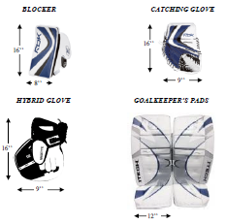
- Goalies are not allowed to pile snow on, in or around the crease in an attempt to help stop or slow the ring.
- Goalies cannot put any part of their stick in or on top of the ring unless it is in the act of making a save.
- If the goalkeeper throws the ring over the defensive blue line, there will be a 5 second count violation where their team cannot touch the ring until the opposition has touched it.
  - The goalie can pass the ring over the blue line with their stick without violation.
- The goalie must have at least one foot inside the crease when throwing the ring out of the crease.
- The goalie can drop the ring outside of their crease and play it using their stick or skate only if their possession was not from a Goalie Ring.
- The goalie cannot pull the ring from outside the crease into the crease.
- The goalie may pass the ring through the crease as long as they don’t contact it while it is in the crease.
- The goalie may catch the ring outside of the crease when making as save as long as they immediately drop it and play it legally.
- The goalie must be completely off the ice before an acting goalkeeper player can enter the crease
- An acting goalkeeper player can pass or throw the ring over the defensive blue line but there is a 5 second count violation for each.
- For a goal to occur, the ring must cross the goal line completely.
For the ring to be considered in the crease, any amount of the ring can be touching the crease or be completely inside the crease.

Skills and Drills

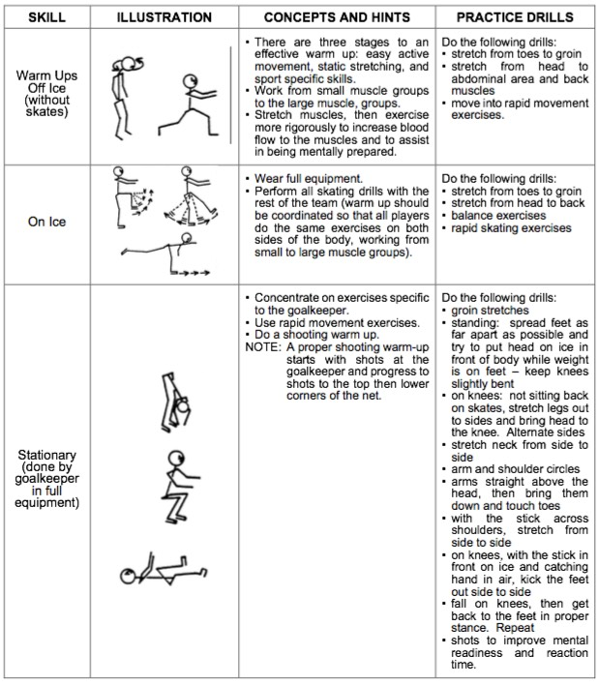

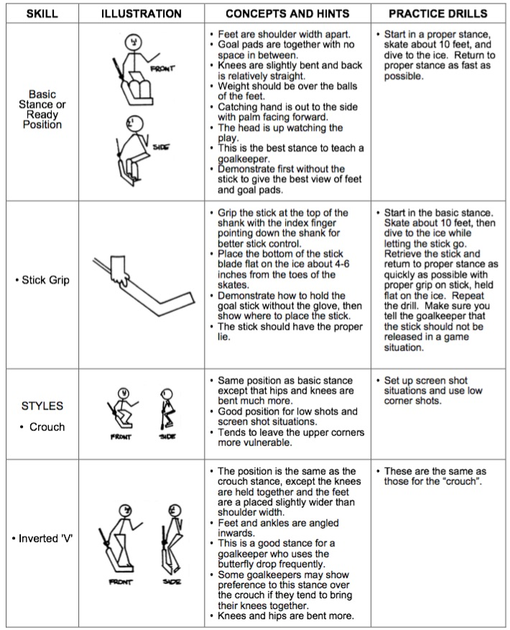

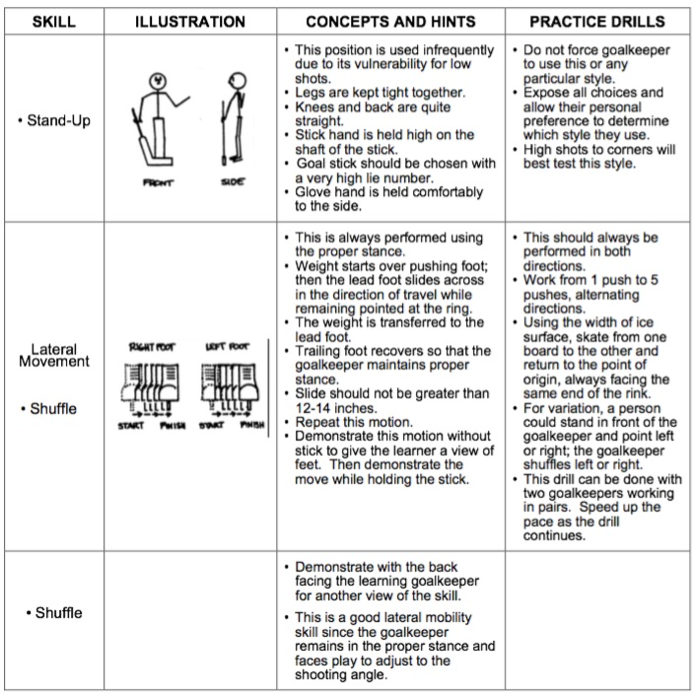

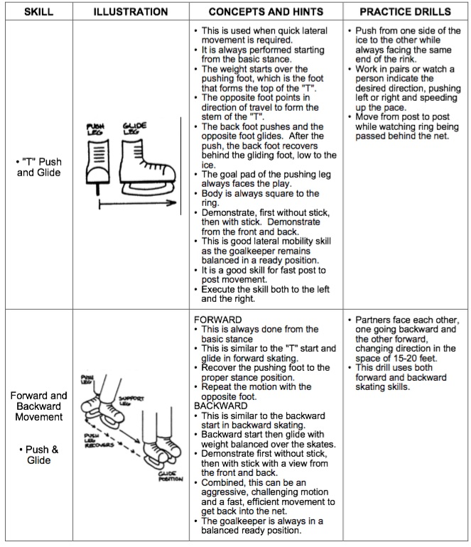

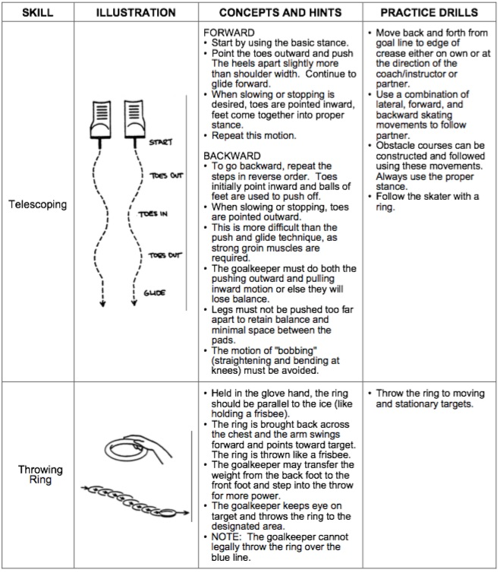

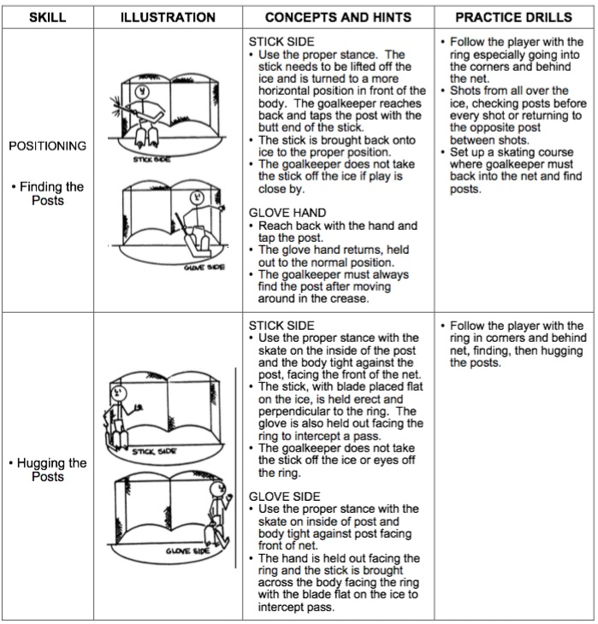

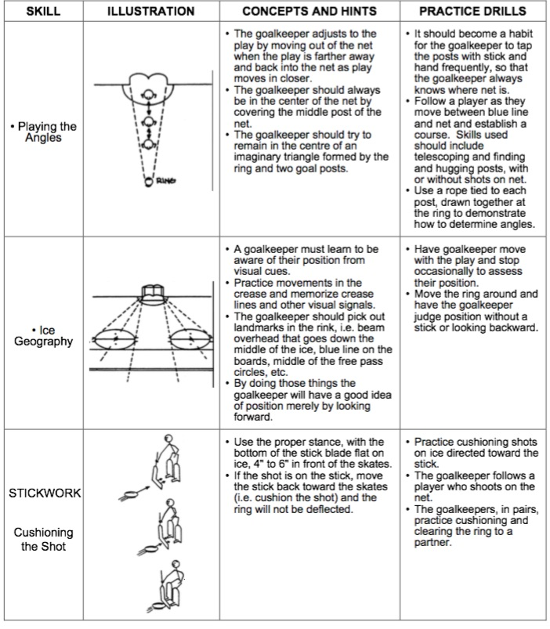

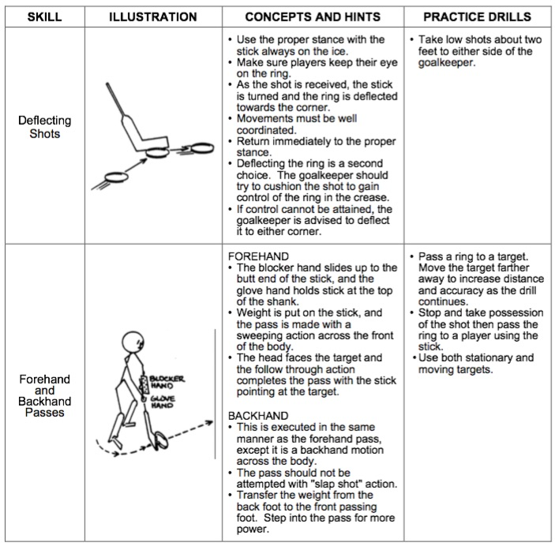

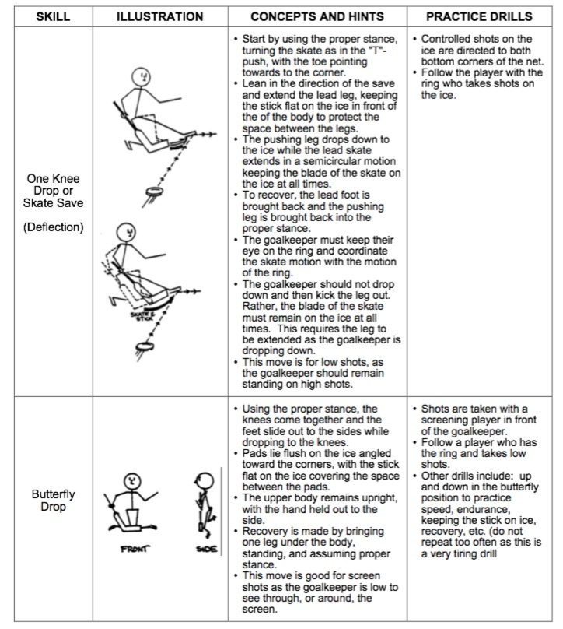

Ringette Practice Plans Worksheet

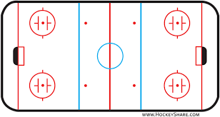

Time:

Time:

Time:

Time:

Time:

Time:

Time:

Time:

Time:

