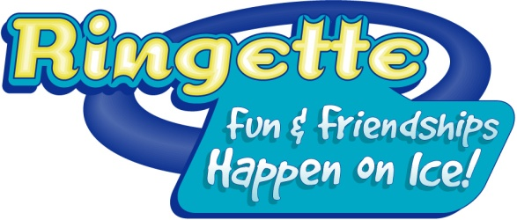

COME TRY RINGETTE
Follow up Report

In order to receive funding assistance for the event the report must be completed in full and the CTR Kit must be returned with all of the contents.
Local Association:
CTR Coordinator:
(Must be trained in the CTR system)
1. What date and time did you hold your event?

2. How many participants pre-registered for your event?

3. How many participants showed up for the event?
4. How many volunteers worked at the event?

5. Please note how you distributed posters in your community (check all that apply):
Attached to Come Try Ringette Posters
During a Gym Ringette session at a school
School mail outs, not associated with Gym Ringette
Distribution via parents and players
Distribution by parents and players
Posting in schools
Posting at the Arena
Daycares or kindergartens
Other, please specify

6. How many participants registered to play Ringette from the Come Try Ringette Event?

7. Please list names, ages and whether or not they registered to play.

8. Other Comments:

