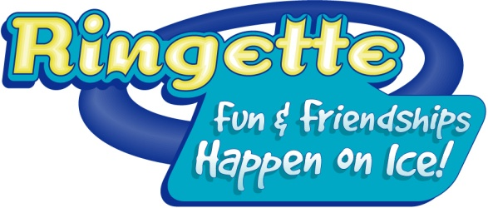

COME TRY RINGETTE
Follow up Report

In order to receive funding assistance for the event the report must be completed in full and the CTR Kit must be returned with all of the contents.
Local Association:
CTR Coordinator:
(Must be trained in the CTR system)

EVENT DATE AND LOCATION:
1. What date and time did you hold your event?

2. How many participants pre-registered for your event?

3. How many participants showed up for the event (please specify male and female separately)?

4. How many attendees became registered members (please specify male and female separately)?
5. How many volunteers worked at the event?

6. Please note how you distributed posters in your community (check all that apply):
Attached to Come Try Ringette Posters
During a Gym Ringette session at a school
School mail outs, not associated with Gym Ringette
Distribution via parents and players
Distribution by parents and players
Posting in schools
Posting at the Arena
Daycares or kindergartens

7. Please include report showing all names, ages and indicate on report if they registered to play this season.

8. Other Comments:

