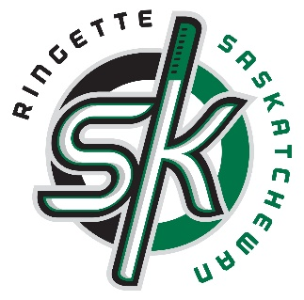

2018 Ringette Saskatchewan Conference
June 2, 9:30-4:30pm
Executive Plaza Hotel (4025 Albert St.)
Regina, Saskatchewan
About the Conference
The conference is for local association board members, coaches, officials, and other interested stakeholders. It consists of one full day of forward thinking, solutions, learning, networking, and professional development.
This conference is strongly encouraged as a majority of the day will be dedicated to Ringette Canada’s Competition Review, which has 61 recommendations that will impact the future of competition in our sport.
Desired Outcomes
The conference will strengthen Ringette in Saskatchewan by:
- Improved strategic alignment with NSO policy regarding certified female coach on every bench
- Comprehensive understanding of Ringette Canada’s Competition Review Report
- Practical ways to integrate, implement, and work together on alignment
- Professional Development
- Collaborating to protect the positive ringette culture
- Opportunity to connect and interact with other coaches for the purpose of exchanging information and potentially developing new contacts
Registration
25 members per association. Associations have until May 18 to register. Associations that want to send more than 25 individuals will be welcomed once the May 18 registration closes and we see if some associations didn’t send the amount they were allowed.
Click here to register for the conference
Preconference work
Once registration closes individuals registered will be sent preconference work to complete before attending June 2. This will prepare you for the day and discussions.
Schedule
9:30-9:45 | Opening Remarks  Ringette Saskatchewan
9:45 -10:45 | Certified Female Coach Policy  Natalie Muller- Ringette Canada
10:45-11:00 | Ringette Alberta Experience with Policy  David Myers- Ringette Alberta Executive Director
11:00-12:15 | Competition Review:  Overview Recommendations/Questions
12:15-1:00 | Lunch (Will be Provided)
1:00-2:30 | Competition Review: Outcomes  What does this mean to you: the local association  Collaborative interactive working session dedicated to practical ways to integrate, implement, and work together on alignment of things coming out of the Competition Review
2:30-2:45 | Break
2:45-4:00 | Breakout session for Board Members. What is Good Governance? How to run a successful Board? Respecting difference of opinions? Seeing the Bigger Picture? Implementing Change?  Wayne Hellquist  Breakout session for Coaches. Collaboration moment/exchanging information. 2 groups split into these two stages  - fundamental ringette skills/physical literacy (Learn to Train and below, which would currently be U12 and below)  - Beyond the foundational stages (Train to Train and up, which would currently be U14 and up).  Amanda/Natalie/Darrell/Mel
4:00-4:30 | Coach Maintenance Requirements  Amanda/Natalie

